­­

**From The Possum’s Room**

For the last week of January the Possum’s focused their learning on Australia Day. The children engaged in a variety of different craft activities which included painting an Australian map, collage of the Australian states map. Stamping red and blue stars and using red playdough as a sensory activity. For the beginning of February the children have been learning about New Zealand and Maori culture specifically for Waitangi day. The children have painted some koru patterns, collage of the Maori flags and we will be engaging in a fried bread cooking activity.

Miss Vinita and Miss Katie

LUCK IS WHAT HAPPENS WHEN PREPARATION MEETS OPPORTUNITY. – *SENECA*

**AROUND THE COUNTRY**  
  
Sustainable Living Festival ---------------------------------1-28

World Wetlands Day ------------------------------------------- 2

Safer Internet Day ---------------------------------------------- 9

Chinese New Year --------------------------------------------- 12

National Apology Anniversary ------------------------------ 13

World Day of Social Justice ---------------------------------- 20

**Rainbow Corner**



the Festival will urge a groundswell of climate awareness and support for the urgent action we need. *In 2021, NSLF events will focus on these themes: ‘Culture of Care’, ‘Emergency Lessons’, ‘Local Matters’ and ‘Reboot and Respond’.* [Find out what events are happening around you **here**](https://www.slf2021.org/)

National Apology Anniversary – 13  
February 13 marks the Anniversary of the National Apology to Australia's First Peoples – a sacred moment in our nation's history that must never be forgotten.There are 10 things you should know about the National Apology [**read here**](https://www.sbs.com.au/nitv/article/2017/02/13/10-things-you-should-know-about-national-apology)

­

**METHOD: Place** the chicken and buttermilk into a bowl and stir to combine. Into a separate bowl, **place** the cornflake crumbs, flour, Cajun seasoning, parmesan, salt, pepper and stir to combine. **Dredge** each piece of chicken in the breadcrumbs and **place** the crumbed chicken onto a tray lined with baking paper, drizzle with a little olive oil and **bake** in a preheated oven (200 C) for 10 minutes or until chicken is golden and cooked through. **To make the Zesty Lime Sauce:** **Place** the yoghurt, lime zest and juice, garlic, coriander, olive oil and salt into the jug of a food processor and blitz for 1-2 minutes or until lusciously combined. **To assemble the tacos**: **Top** warmed tortillas with lime avocado, shredded iceberg lettuce, crispy Cajun chicken bites and drizzle with zesty lime yoghurt sauce. Enjoy **x**

*Recipe and Image from* ***My Lovely Little Lunch Box*** *mylovelylittlelunchbox.com/2020/04/20/crispy-cajun-chicken-tacos/*

**INGREDIENTS  
*Crispy Air Fried Cajun Chicken:***

500 grams **chicken breast**, *cut into bite-sized pieces*

1/2 cup (125 ml) **buttermilk**

2 1/2 cups (300 grams) **corn flake style breadcrumbs**

2 tablespoons **flour**

2 1/2 tablespoons **store-bought Cajun seasoning**

2/3 cup (90 grams) **parmesan cheese**, *grated*

**sea salt and pepper**, *to season*

***Zesty Lime Sauce:***

1 cup (250 grams) **Greek style yoghurt**

juice and zest of 1 **lime**

1 clove **garlic**, *minced*

1 handful **coriander leaves**

1 tablespoon **olive oil**

**sea salt**, *to season*

***Tacos:***

6 **tortillas**, *warmed according to packet instructions*

1 **avocado**, *mashed with the juice of 1* ***lime***

2 cups **iceberg lettuce**, *finely shredded*

PREP 10 min | COOK 10 min | MAKES 6

**CRISPY CAJUN CHICKEN TACOS**

*Resilience can be learned like any other skill. It takes practice and patience. Check out this collection of books that teach resilience.*

**THE MOST MAGNIFICENT THING  
Ashley Spires | 1 - 4 *Award-winning author and illustrator Ashley Spires has created a charming picture book about an unnamed girl and her very best friend, who happens to be a dog.*** *The girl has a wonderful idea. "She is going to make the most MAGNIFICENT thing! She knows just how it will look. She knows just how it will work. All she has to do is make it, and she makes things all the time. Easy-peasy!" But making her magnificent thing is anything but easy, and the girl tries and fails, repeatedly.*

**PETE THE CAT: I LOVE MY WHITE SHOES**

**Eric Litwin | AGE 1 - 4  
*Pete the Cat goes walking down the street wearing his brand-new white shoes. Along the way, his shoes change from white to red to blue to brown to WET as he steps in piles of strawberries, blueberries, and other big messes!*** *But no matter what colour his shoes are, Pete keeps movin' and groovin' and singing his song...because it's all good.*

**ISH**[Peter H. Reynolds](https://www.amazon.com/s/ref=dp_byline_sr_book_1?ie=UTF8&field-author=Peter+H.+Reynolds&text=Peter+H.+Reynolds&sort=relevancerank&search-alias=books) **| AGE 4 - 8  
*A creative spirit learns that thinking “ish-ly” is far more wonderful than “getting it right” in this gentle fable from the creator of the award-winning picture book The Dot.*** Ramon loved to draw. Anytime. Anything. Anywhere. Drawing is what Ramon does. It’s what makes him happy. But in one split second, all that changes.

SUSTAINABLE LIVING FESTIVAL (NSLF) 1 - 28  
In this age of environmental, social and economic disruptions it Is vital that we don't lose sight of the bigger picture and keep our eye firmly focused on the mission to sustain our planet. In the wake of Australia experiencing unprecedented climate events,

Discuss more typical responses to anger or fear. Talk about how a smile during a serious moment can be misunderstood. Once the behaviour is verbalized it is easier for the child to draw up a more appropriate response. If your kiddo uses humour as a tool to alleviate discomfort come up with a different strategy. Commend him on how he has been blessed with a sense of humour. Talk about the right time and place for his antics. You may even want to use a visual or tactile cue to encourage appropriateness. “Put on your left brain, logic hat. It’s time for us to talk about…..” - “My touch is a sign that this is important but not scary.”  
  
In finding out the WHY of the chuckles you will be better equipped to deal with the anger inducing laughter during a serious moment.  
  
Wildenberg, Lori. (2020). *It’s NOT Funny! What to do if your child laughs at discipline****.***Retrieved from https://herviewfromhome.com/its-not-funny-what-to-do-if-your-child-laughs-at-discipline/

**8 QUICK TIPS**   
  
If your child is like most kids and has occasional periods of defiance, there are things you can do to make things easier.

1. Set Expectations
2. Get to the Root of the Behaviour
3. Set your **Child** Up for Good Behaviour
4. Treat Your **Child** As You'd Want to Be Treated
5. **Take** Advantage of Your **Child's** Verbal Skills
6. Establish Absolute Ground Rules
7. Compromise When You Can
8. Discuss Options

Each of these eight tips are elaborated in full [**here**](http://verywellfamily.com/how-to-handle-defiant-children-620106)

Katherine, Lee (2020). *Effective Ways to Handle Defiant Children****.***Retrieved from https://www.verywellfamily.com/how-to-handle-defiant-children-620106

FOCUS: It’s NOT Funny! What to do if your child laughs at discipline

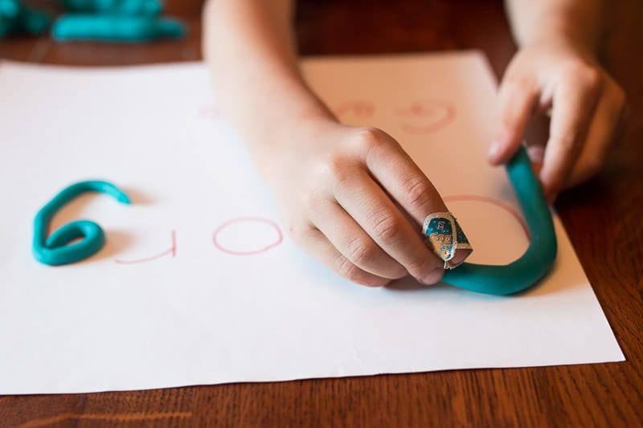

Children love playdough. It’s a brilliant tactile material, great for developing fine motor skills. This simple activity is great for name recognition and spelling.

**You will need:** Homemade or store bought playdough, paper, marker.

**Set up:** Write your child’s name quite large on a piece of paper. Show your child how to make snakes by rolling out playdough, then demonstrate how you can shape the snakes into letters. Allow your child to freely create their name. Ask them if they recognise the letters in their name.

You may like to add additional manipulatives like sequins, toothpicks and buttons. You child can use these to decorate each letter and further emphasise the shape of each letter.

Image and activity from <https://handsonaswegrow.com/play-dough-name-tracing/>

***We love humour. But…when disciplining our kiddos humour isn’t funny. When our child smirks and busts a gut during a serious moment, we feel as if fireworks in our chest are ready to explode.***

**That grin. That giggle. OH! It feels like mocking.** *Let’s consider some things before lighting the fuse.* Humour usually brings people together.  
Humour is a great deflector and distractor.  Humour is a positive way to get attention. humour can be a way to gain or regain control. Humour can be used to manipulate. Humour is an action. But laughter is a reaction.  
  
***Laughter is a physical response to an emotional trigger.*** Have you ever said, *“If I don’t laugh, I’m going to cry?”* Sometimes kids get the giggles or act silly when they feel uncomfortable or nervous. They may laugh or act like a jokester to reconnect or reaffirm the parent-child relationship. When mum or dad express anger, it is possible the child is attempting to make things better with joke to defuse the situation. It’s also likely he is scared or uncomfortable and that a laugh is his reaction rather than to fight or take flight.  
  
**Observe your child. Give him the benefit of the doubt. Perhaps his reaction is due to fear. Maybe it is a way to re-establish the relationship.** ***No matter the reason, mum and dad must not ignite the wick. Stay in control.***  
  
During the moment mirror his non-verbal behaviour: “You are smiling.” Ask, “Are you feeling uncomfortable?” After the event inquire, “Why do you think you smiled when I was speaking with you?”

**PLAYDOUGH NAMES**

Stay calm and make sure to also use your face to communicate, e.g. I know you are sad when mummy goes (show sad face) but you have a great time with (carer/ friend’s name) (show happy face)

**If your child is a “little thinker” and anticipates separation well before the event, we recommend:**

1. Create a ‘days of the week’ chart so your child is aware of school days and the weekly routine.
2. Normalise the anxiety or worry by validating your child’s feelings e.g. “You’re a bit worried about going to school and being apart from mummy. It’s OK to feel worried”
3. Encourage your child to persevere even though they are worried by reflecting on their past experiences. e.g., “You were worried about leaving mummy last week but you were very brave and went to school and then you had lots of fun”, “you were worried when we went to the party on the weekend but then you settled in and had a great time”
4. Create some catch phrases with your child to assist them to manage. Use these phrases on multiple occasions and have your child repeat them back to you. e.g., “I just need to play some games then I’ll get used to it”, “Even though I miss my mummy, I’m OK and my mummy is OK”, “I will have a lot of fun today and mummy will pick me up soon”.
5. Praise your child for being brave and doing things even though they are worried.

Be aware of supporting your child’s worry by allowing him or her to avoid attending pre-school or a feared event as a way of managing their anxiety. This usually exacerbates your child’s anxiety rather than diminishing it.

Rocker, Leonardo. (2011). *The Dreaded Drop-Off!****.*** Retrieved from https://childpsychologist.com.au/the-dreaded-drop-off/

***As some pre-schoolers may not yet be fully cognisant of their identity being separate to that of their parents, it is quite normal that times of separation, like the ‘drop-off’, can be loaded with separation anxiety and distress.***  
  
Other pre-schoolers are already **little thinkers,** able to anticipate future separation thus increasing their anxiety surrounding the morning’s pre-school drop-off.  This child may ask the night before “is it a school day tomorrow?” and then display challenging behaviour from early in the morning in an effort to avoid the anticipated separation.  
  
**Here are a few options for managing this tricky issue of separation anxiety for pre-schoolers and parents alike.** Begin by learning more about your child’s day by having a conversation with your child’s educators. Questions to ask include: – How long does he or she take to settle? – How are his or her play and social skills developing? – How well is he or she communicating?  
  
Your child’s educators can provide valuable feedback around issues such as how well your child is able to do things like share, take turns and manage frustration with peers. If there are significant issues occurring in these areas, difficulty separating from parents and caregivers can reflect your child’s distress at entering an environment where they are having consistent negative experiences. If this is the case, it is important to target the skills and behaviours which are less developed and causing difficulty as a first step  
  
If educators report that your child settles quickly and is reaching normal developmental milestones around play, communication and social skills, you can then target the issue of separation and assist your child to learn to cope with this process.  
  
**If your child happily gets ready for school and appears quite relaxed until the actual moment when you are leaving, we recommend:**  
  
Keep drop-offs short and your actions consistent e.g. Spend a period of time settling your child by engaging them with a carer and/or activity. It may help if you narrate your actions, so your child is clear about what is happening “Let’s take you over to (carer) or Let’s go and set you up with the blocks…. It’s time to say goodbye now. Mummy will come and collect you at (time). OK Mummy is going now, (kisses/hugs) bye.

HEALTH & SAFETY: The Dreaded Drop Off

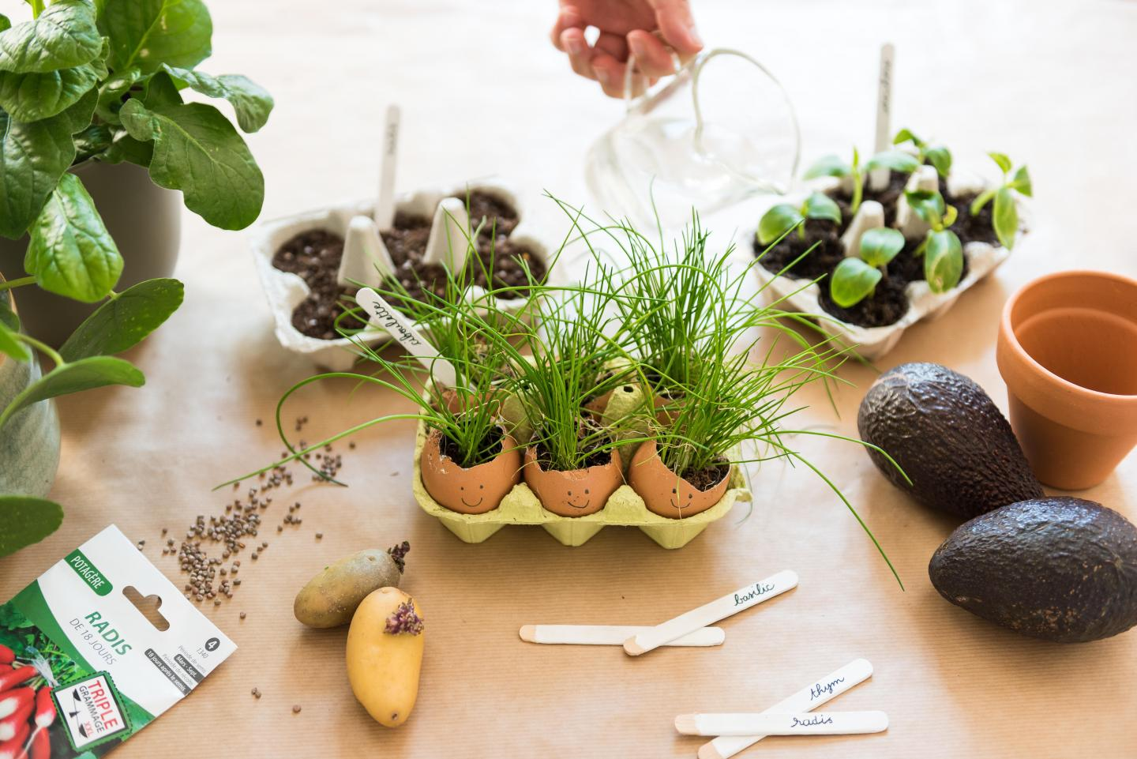

Image & Activity Source: klorane.com/au-en/content/tips-eco-friendly-school-holiday-activities

**EGG HEADS   
  
Gardening is a great way to keep children busy, whether you have a large garden, a small patio or even an apartment without a balcony, you can always find a way to do some planting and bring a bit of nature into your children's lives.**

All you need Is some empty egg cartons (even egg shells), a bit of soil, some seeds... You don't need much to have a good time! Simply fill the cartons with a little soil, add your seeds and water.  
  
Choose fast-growing seeds. Radishes, fava beans, dried beans, lentils and chickpeas, etc. are all ideal for planting with children, because their journey from seed to shoot to plant is fast and they require little care - just a little water and you’ll be seeing progress every day. Some flowers, such as nasturtiums and marigolds, grow quickly and can be used to decorate salads or desserts.



**Happy Birthday**

**Jamie 3rd**

**Ava 8th**

**Charlie C 22nd**

**Yuvraj 22nd**

**Rose 24th**

**We hope you all have an amazing day**



­

**CONGRATULATIONS**

**Alexis Coolwell**

**You are our monthly prize draw winner**

**Please ensure regular payments are made on your account to avoid your account getting too high.**

**If you wish to discuss you account please see Kylie or Amanda in the Office.**

MUSIC AND DANCE

If you’ve ever witnessed pre-schoolers grooving to music, you can’t help but smile. They obviously love the feeling of moving to the tunes we play for them. But music and dance are much more than just fun activities for children.  In fact, it’s very beneficial for pre-schoolers to participate in these “performing arts”.  Here’s why:

Music and dance engage the brain: Children learn new things, like sounds, words and patterns through music. And with dance, they can explore and control their body movements.  These activities are great for development and stimulate connections in the growing brain.

It helps cultivate communication skills: Bringing together kids with songs, rhymes and actions lets them discover how to interact and connect with others.  They develop listening and social skills that will give them self-confidence and better prepare them for school.  
  
Music and dance allows kids to express themselves-  
Happy, nervous, tired?  Engaging in creative activities lets kids release their emotions and express their feelings.  It’s a fantastic opportunity for children who aren’t yet able put their thoughts into words.  
  
It helps foster physical skills: Young musicians and dancers learn skills like balance, control and coordination.  Singing and movement is also good aerobic exercise- linked to stress reduction, physical fitness and overall good health.

Music and dance contribute to creativity and imagination. With children spending more time in front of screens rather than physically playing, music and dance encourages them to be curious and imaginative.  This creative outlet can also give them opportunities to learn about other cultures through the arts.

Source: <https://www.nvrc.ca/notices-events-blog/active-living-blog/5-benefits-music-and-dancing-preschoolers>

**National Quality Framework** | Quality Area 1:   
Element 1.1 – *Program.* The educational program enhances each child’s learning and development.

CRAWL CHASE

When was the last time you got on your hands and knees and   
crawled like a baby? Give it a go, it is quite tiring and is a great

brain workout too. This activity is simple and requires no equipment just a little space.

It is tag on all fours. Take turns being ‘in’. Everyone gets into crawling position and crawls away trying to avoid being tipped! *Have fun.*

YOUR SERVICE NAME Rainbow Corner  
  
Email: [rainbowcorner@bigpond.com](mailto:rainbowcorner@bigpond.com) Phone number: 07 3805 3627